PROJECT REPORT

**PROJECTTITLE:** Laptop Request Catalog Item

**TEAM ID:** NM2025TMID18738

**TEAM LEADER:** B LOGESHWARI

**TEAM MEMBER**: S SANDHIYA

**TEAM MEMBER:** R SASIPRIYA

**TEAM MEMBER:** S SATHYA

**DEPARTMENT:** COMPUTER SCIENCE

**COLLEGE NAME:** L.N GOVERNMENT COLLEGE

**YEAR:** 3RD YEAR

Laptop Request Catalog Item

Table of Contents

1. INTRODUCTION 3

1.1Project Overview 3

1.2 Purpose 3

2. IDEATION PHASE 3

2.1 Problem Statement 3

2.2 Empathy Map Canvas 4

2.3 Brainstorming 5

3. REQUIREMENT ANALYSIS 6

3.1 Customer Journey map 6

3.2 Solution Requirement 6

3.3 Data Flow Diagram 7

3.4 Technology Stack 9

4. PROJECT DESIGN 11

4.1 Problem Solution Fit 11

4.2 Proposed Solution 12

4.3 Solution Architecture 12

5. PROJECT PLANNING & SCHEDULING 13

5.1 Project Planning 13

6. FUNCTIONAL AND PERFORMANCE TESTING 13

6.1 Performance Testing 13

7. RESULTS 14

7.1 Output Screenshots 14

8. ADVANTAGES & DISADVANTAGES 17

9. CONCLUSION 17

10. FUTURE SCOPE 18

# 1. INTRODUCTION

## 1.1Project Overview

The *Laptop Request Catalog Item* project in ServiceNow involves creating a user-friendly and automated form that allows employees to request laptops through the organization’s ServiceNow platform. This item streamlines the hardware request process, ensuring faster approvals, accurate tracking, and better inventory management.

## 1.2 Purpose

The primary goal of this project is to simplify and digitalize the laptop requisition process. By implementing this catalog item, the organization can improve service delivery, reduce manual intervention, and ensure a transparent, traceable workflow for IT hardware provisioning.

# 2. IDEATION PHASE

## 2.1 Problem Statement

|  |  |
| --- | --- |
| Date | 17 June 2025 |
| Team ID | LTVIP2025TMID30280 |
| Project Name | laptop request catalog item |
| Maximum Marks | 2 Marks |

Employees face delays and inefficiencies when requesting laptops through manual or email-based systems. Lack of standardized processes leads to confusion, approval delays, and inventory mismanagement. There is a need for a centralized and automated solution to manage laptop requests effectively.

## 2.2 Empathy Map Canvas

|  |  |
| --- | --- |
| Date | 17 June 2025 |
| Team ID | LTVIP2025TMID30280 |
| Project Name | laptop request catalog item |
| Maximum Marks | 4 Marks |

Section Description

**Think & Feel** Captures the user's internal thoughts, worries, aspirations, and priorities.

**Hear** Reflects what the user hears from friends, colleagues, influencers, or media.

**See** Describes the user's environment, what they observe, and what competitors offer.

**Say & Do** Outlines the user's behavior, public attitude, and how they interact with others.

**Pain** Identifies fears, frustrations, and obstacles the user faces.

**Gain** Highlights the user's goals, needs, and what success looks like to them.

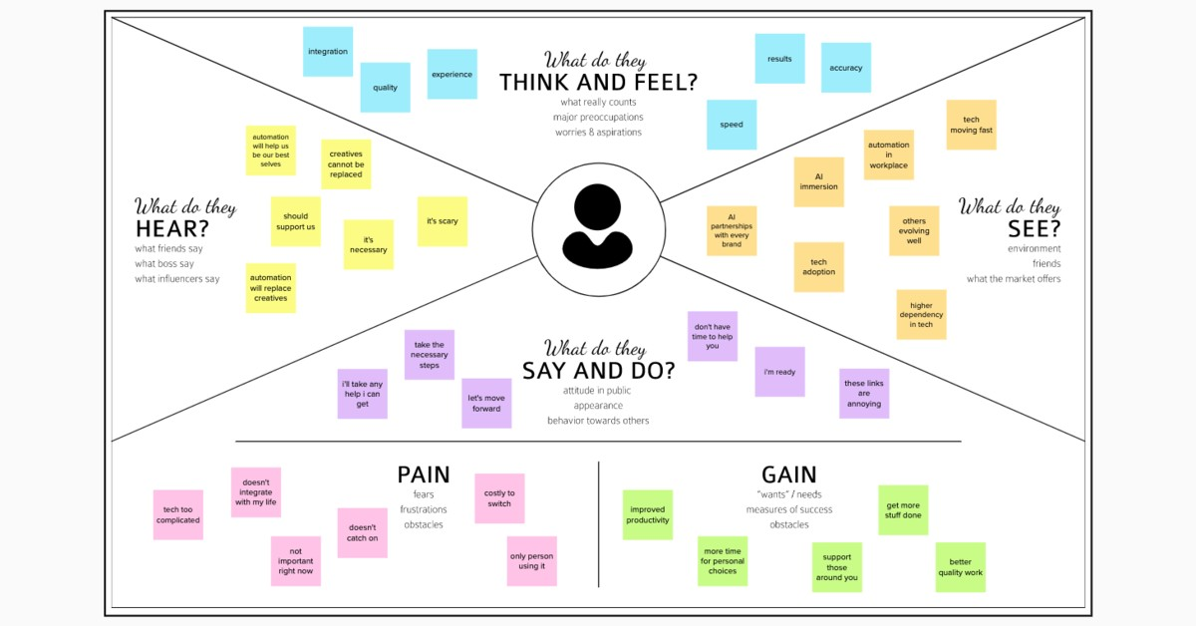

## 2.3 Brainstorming

|  |  |
| --- | --- |
| Date | 17 June 2025 |
| Team ID | LTVIP2025TMID30280 |
| Project Name | laptop request catalog item |
| Maximum Marks | 4 Marks |

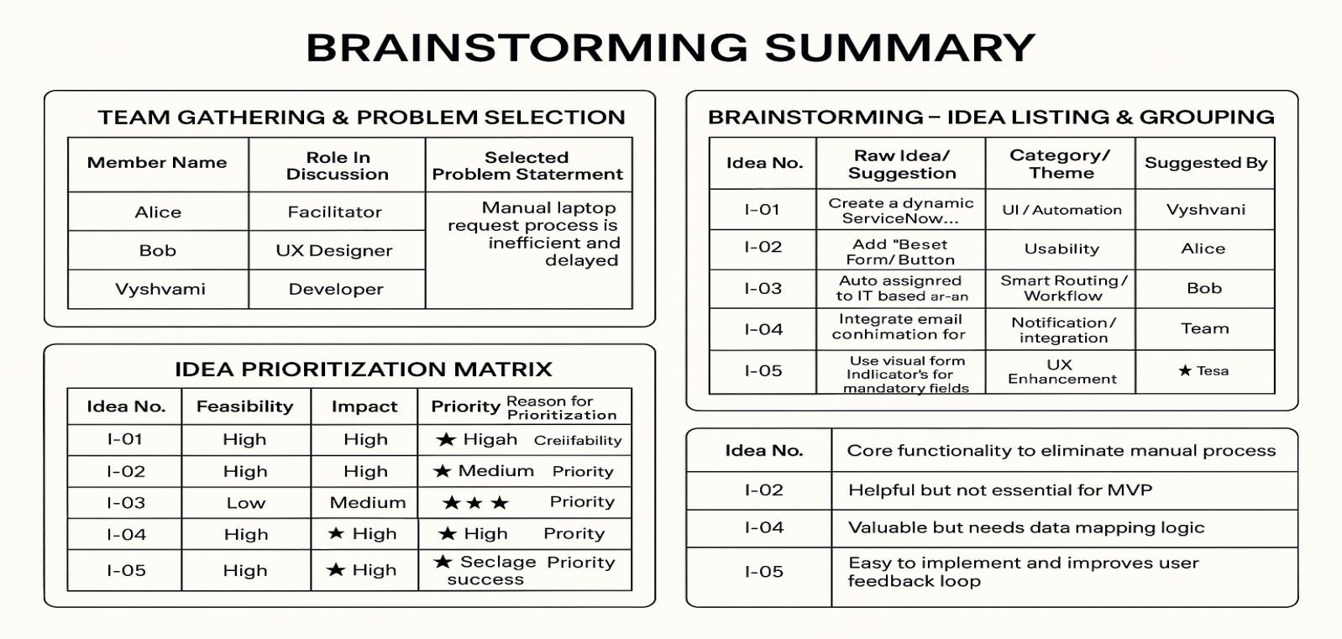

# 3. REQUIREMENT ANALYSIS

## 3.1 Customer Journey map

This visualizes the end-to-end experience of an employee requesting a laptop:

**Awareness**: Employee realizes the need for a laptop.

**Access**: Logs into the ServiceNow portal and navigates to the Hardware Catalog.

**Interaction**: Fills out the dynamic Laptop Request form (selects model, RAM, processor, accessories).

**Approval**: Request is routed to the manager for approval.

**Fulfillment**: Upon approval, a task is assigned to the Hardware team.

**Closure**: Laptop is delivered and the request is marked complete.

**Pain Points Addressed**: Manual delays, lack of clarity, and inconsistent data entry.

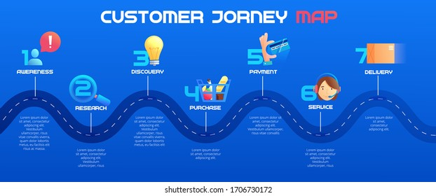

## 3.2 Solution Requirement

|  |  |
| --- | --- |
| Date | 17 June 2025 |
| Team ID | LTVIP2025TMID30280 |
| Project Name | laptop request catalog item |
| Maximum Marks | 4 Marks |

**Functional Requirements:**

Following are the functional requirements of the proposed solution.

**FR Functional Requirement**

**Sub Requirement (Story / Sub-Task)**

**No. (Epic)**

- Registration through Form <br> - Registration via Gmail <br> -

FR-1 User Registration

Registration via LinkedIn

FR-2 User Confirmation - Confirmation via Email <br> - Confirmation via OTP

**Non-functional Requirements:**

Following are the non-functional requirements of the proposed solution.

NFR Non-Functional No. Requirement

**Description**

NFR-1 Usability